Apigee & Kubernetes

# Step one:

In the search bar search for APIGEE and enable its API:

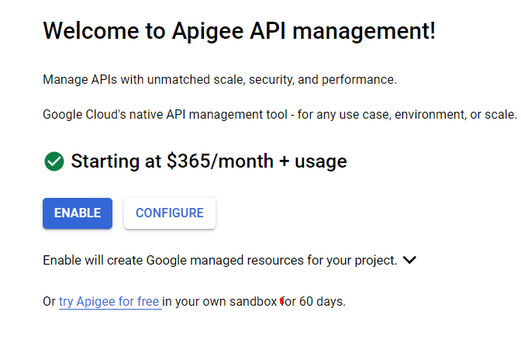

Wait a couple of minutes and then press on networking:

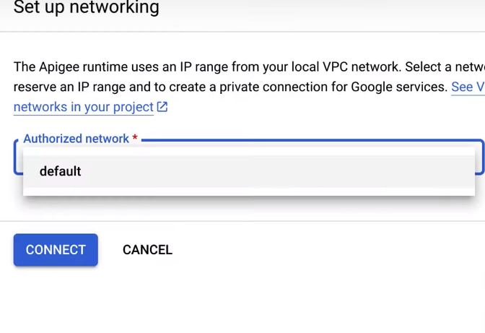

After networking step finish choose this option:

Finally choose the region and enable public internet access:

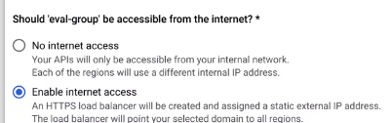

## Step 2:

create a new API proxy:

After that name your proxy and choose the base path and paste the link of your API:

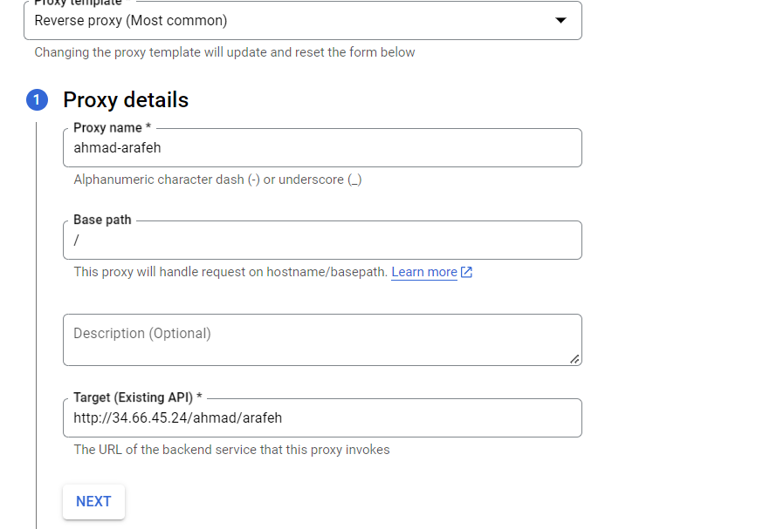

Then select eval environment and create:

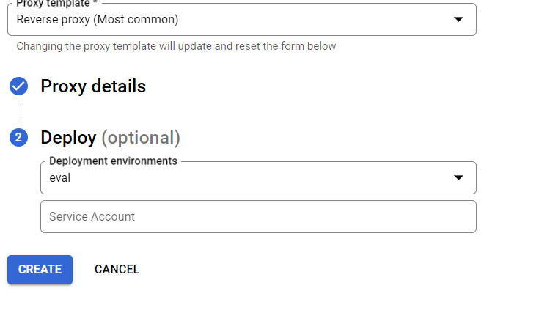

## Step 3:

After that go to your API proxy and go to develop, then go to preflow of the Proxy endpoint and change the base path to your name:

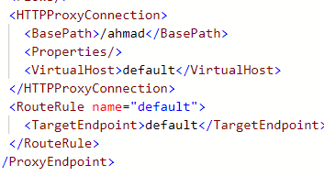

Then it would be automatically changed also on post flow for the proxy endpoint.

Next, go to target API endpoint and press on preflow or post flow and make sure that your microservice URL is correct:

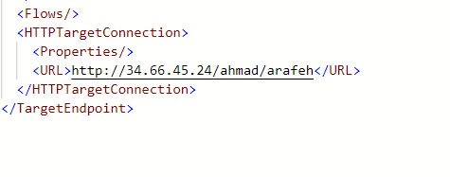

## Step 4:

After that go to the overview page and from there press on the URL and change the path in the URL to your path:

SIMPLE AND STUIPD !